Downloading Conference App Presentations

Go to:
- More > Change Events > Past > 2025 CACUBO ANNUAL CONFERENCE (screen shot below)
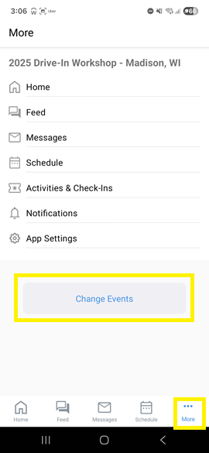 | 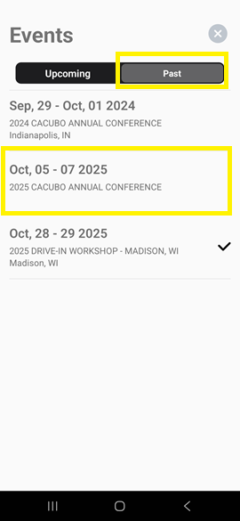

- Once you sign in (top right), you should be able to see the slides and download them:
